Green Society Public School
D-

Ratnanagar-7, Sauraha, Chitwan
Annual Examination-2082
Class: One Time: -1 hr. F.M: - 25
Sub: HRHG
Name: Roll No.: Sec.:
________________ ______________ OBT.MARKS:
INVIGILATOR EXAMINER
Q no.1] Match the following. (3)
Indoor games To video call
Mobile Chess/ludo
Stop Dashain
Festival Domestic animal
Sheep Good habit
Brushing teeth Red light
Q no.2] Write true or False. (3)
- We can play football inside the room.
- Mobile helps us to connect with others.
- We cross the road by zebra crossing.
- Parrot is water animals.
- We get food from plants.
- My family does not love me.
Q no.3] Write the missing letters. (3)
Pokh_____ra Broth____r Garli_____
_____rush Pee____al Ja___mine
Q no.4] Write any names. (6)
- Herbs :- ______________________ , _____________________.
- Birds :- _______________________, _____________________.
- Wild animals :- _________________, _____________________.
Q no.5] Answer the following questions. (6)
- What is your father’s name?
Ans:- _____________________________________________________________________.
- How many family members are there in your family?
Ans:- _____________________________________________________________________.
- What are shrubs?
Ans:- _____________________________________________________________________.

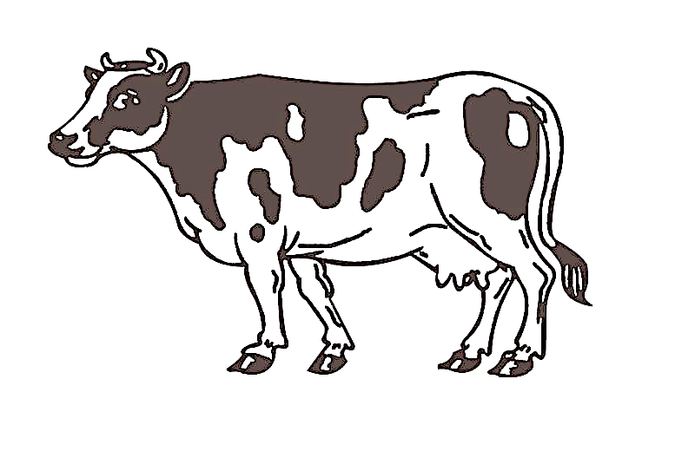
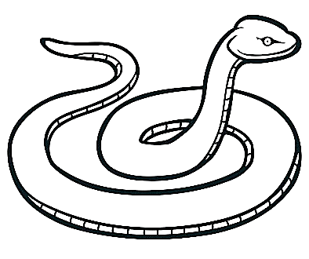
Q no.6] Write the names of the following animals. (4)

The End

